8.8- Graphing Rational Functions Notes (Day 3)

Transformations of Rational Functions

Parent Function is $f(x)=\frac{1}{x}$
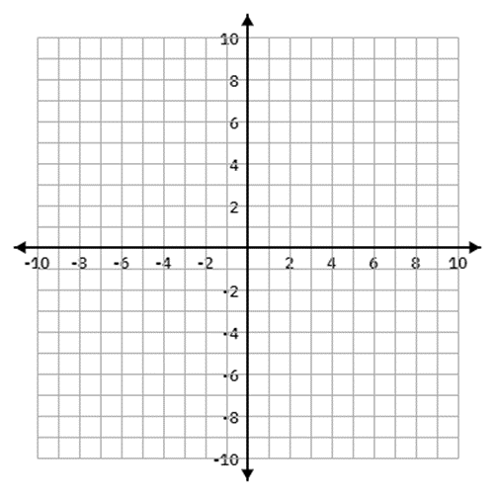

The parent function can transform in the following ways:

Horizontal Shifts Vertical Shifts Vertical Stretch Vertical Reflection

Examples: List all transformations for the following and include the domain and range.

1) $y=\frac{1}{x-4}$ 2) $y=\frac{1}{x}+3$ 3) $y=\frac{1}{x+2}-5$ 4) $y=\frac{1}{x+3}-2$

5) $y=\frac{-1}{x}$ 6) $y=\frac{2}{x}+1$ 7) $y=\frac{-1}{x+3}$ 8) $y=\frac{-3}{x+4}+2$

9) Write the equation for a rational function that has been moved right 3, up 5, stretched vertically by a factor of 2 and is reflected over the x-axis.

10) Write the equation for a rational function that has been moved left 4, up 3, and is reflected over the x-axis.

Asymptotic Behavior
This describes what a graph is doing as it approaches an asymptote.
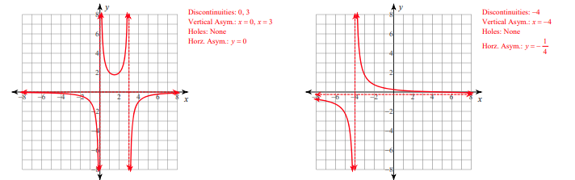
“As x approaches an asymptote from a certain direction, y responds by approaching either positive or negative infinity”

